The Portland Home Energy Score Program
Starting January 1, 2018, the city of Portland will require a Home Energy Score be performed prior to publicly listing a home for sale. The Home Energy Score must be provided to all potential buyers, their realtors and the City of Portland while it’s for sale and the score be posted on all listings (MLS, Craigslist, Zillow, Trulia, For Sale By Owner etc.). There is a $500 fine for noncompliance.
- The ordinance does not require you do upgrades or meet any level of energy efficiency, you only need to make it available to potential buyers.
- To see a sample report go to: https://www.portlandoregon.gov/bps/article/657789
- To view the ordinance, exemptions and waivers see: https://www.portlandoregon.gov/bps/article/655310
- The ordinance only applies to the City of Portland. City boundary map below.
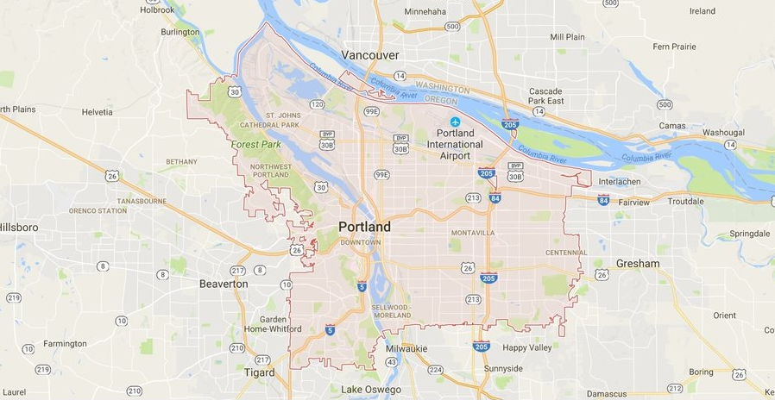

What is a Home Energy Score?
​A Home Energy Score is an energy audit that prioritizes energy upgrades and details the cost savings of each upgrade. It's also used as a method of comparing homes based on energy use, like miles per gallon used for vehicle efficiency.

What is Measured in a Home Energy Score
A Home Energy Score only considers the home’s assets, which include the building attributes, envelope, and equipment. It does not include personal behavior, appliances, or lighting.
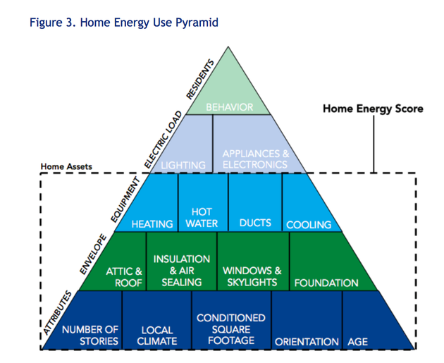

The “score” given to each home is based on how much energy a home is expected to use compared to other homes in the United States. A score of 1 means the home is expected to use more energy than 85% of the homes in the United States. A score of 10 means the home will use less energy than 90% of homes in the United States. The "score with improvements" is the score if all the recommended energy upgrades are completed. See below.
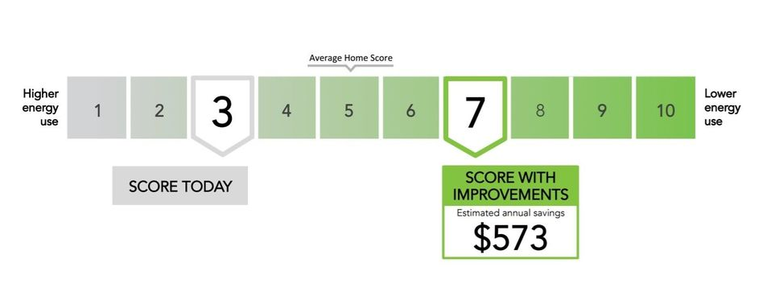
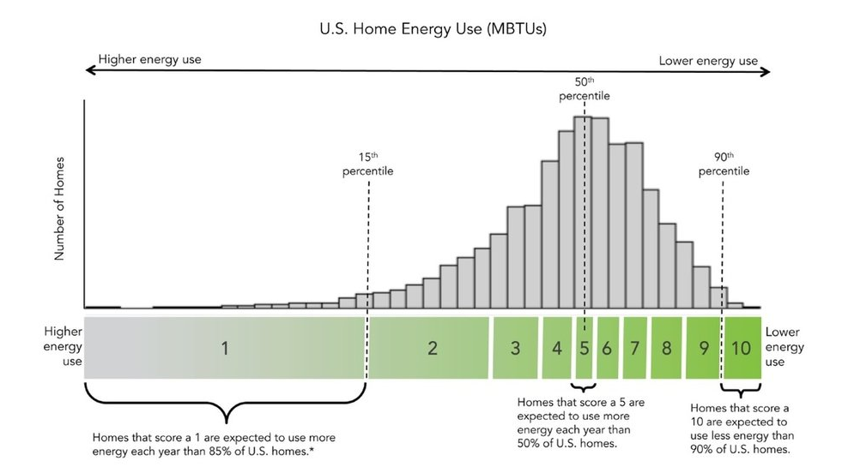

A Home Energy Score report also provides a list of suggested upgrades. If every one of the upgrades were completed, the home would go from a score of 3 to a 7 (see above photo) and you could expect to save $573 a year. Energy upgrades that do not have a ten-year payback will not be listed.

